*Le Commandant Charcot* Opens Doors

to the Arctic Before Any Other Ship

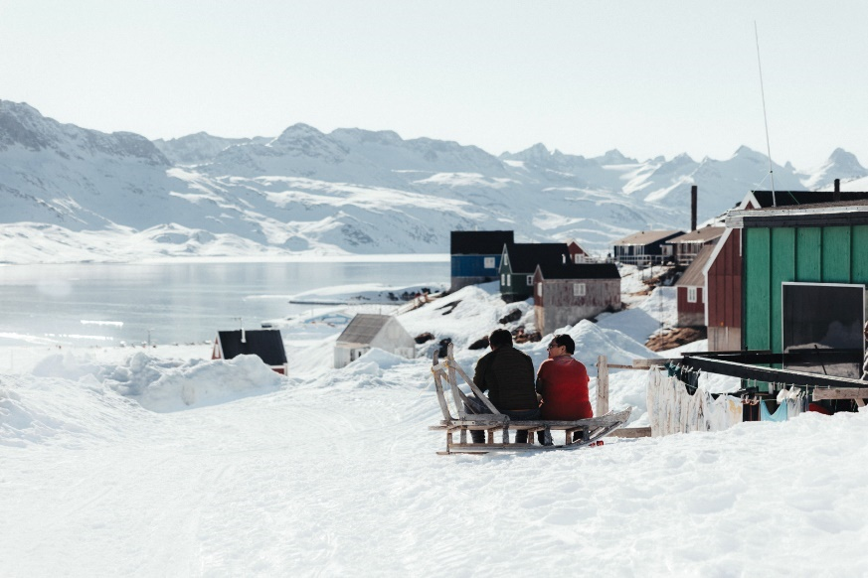Being alone on the edge of the world is the promise as PONANT launches sales aboard *Le* *Commandant Charcot* to the Baffin Sea for summer 2025. PONANT cultivates its pioneering spirit with a first sailing is on 6 March, before any other ship. Thirteen departures and seven itineraries, including two brand new ones, to explore the Great North.

An opportunity to experience the special atmosphere of a boreal spring in total privacy beckons. *Le Commandant Charcot*, the world’s only luxury icebreaker, offers her guests an early unique experience as the ship sails deep into the ice at the end of winter. No other ship can reach these outer limits of the Arctic so early in the year. “*We will* *be entering another world that we have never seen before,”* says Captain Garcia. All seven itineraries give pride of place to exploration. Depending on departures, Nordic skiing polar trek, dog sledding, kayaking, polar diving and ice fishing are among the highlights, as close as it is possible to be to nature.

[Discover these explorations](https://en.ponant.com/cruises/on-board/vessel-le-commandant-charcot?periode%5B%5D=2025_03&periode%5B%5D=2025_04&periode%5B%5D=2025_05&periode%5B%5D=2025_06&periode%5B%5D=2025_07&periode%5B%5D=2025_08&periode%5B%5D=2025_09)

Thirteen departures, seven itineraries, from 6 March to 5 September 2025

Greenlandic spring and ice-covered Disko Bay

An exceptional voyage from the Gulf of Saint Lawrence to Greenland’s southwest coast where the sheer whiteness dominates more than ever. Villages are still locked in the ice, their communities cut off from the world. “*By arriving two months earlier than any other ship,* Le Commandant Charcot *can bring supplies to local communities, particularly fresh produce,*” explains José Sarica, R&D Expedition Experience Director. Encounters take on a whole other dimension as Inuits and Mi’kmaqs share their spring traditions.

Another out-of-the-ordinary voyage given the time of year is the one exploring ice-covered Disko Bay, an immersion in the Greenlandic spring. Each exploration has its activities, whether skiing on trackless snow-covered paths, hiking to breathtaking views of ice cathedrals, discovering Arctic wildlife or chasing the Northern Lights… every activity reveals new facets of these territories.

[*From the St.Lawrence to Greenland, the Last Moments of Winter*](https://en.ponant.com/the-arctic-from-the-st-lawrence-to-greenland-the-last-moments-of-winter-cc060325-9), Saint Pierre and Miquelon – Reykjavík, from 6 to 21 March 2025

[*Disko Bay: Meeting the Inuit & Discovering the Unknown*](https://en.ponant.com/the-arctic-disko-bay-meeting-the-inuit-discovering-the-unknown-cc210325-9), Reykjavík – Nuuk, 2 departures on 21 March and 17 April 2025

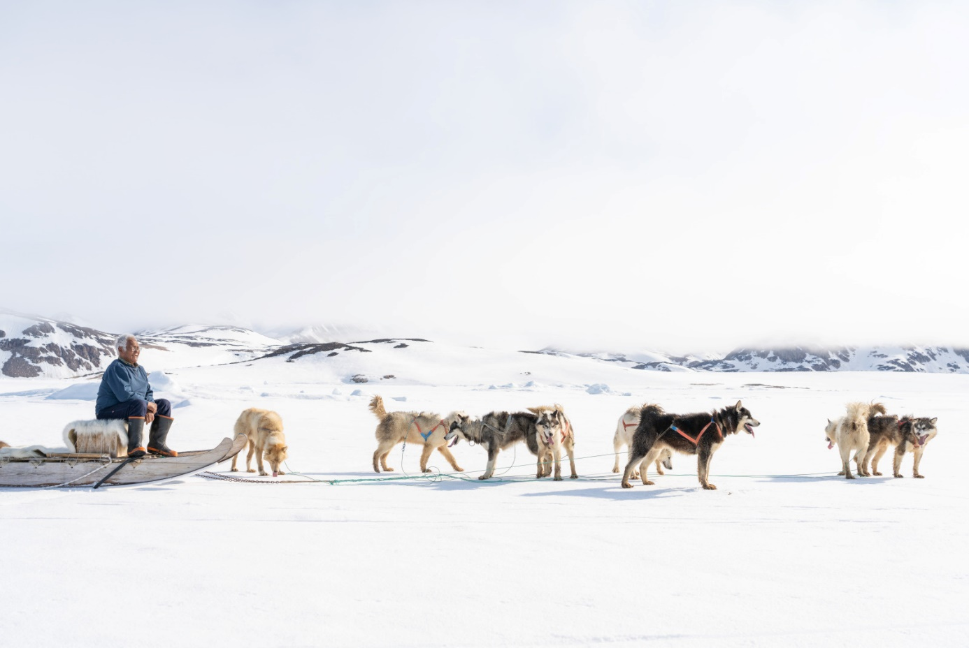

Transarctic, the Quest for the Two North Poles

Summer 2025 will also be the setting of an historic voyage across the Arctic in a quest to find the Magnetic and Geographic North Poles, a point that has only been reached by a few. Aboard *Le Commandant Charcot*, an interdisciplinary group of 20 international researchers will be working together on a major scientific project. Talks, round tables, observations and explanations promise full immersion for guests who will be witnesses to these experts attempts to unravel some of the great mysteries of the Arctic.

[*Transarctic, the Quest for the Two North Poles*](https://en.ponant.com/the-arctic-transarctic-the-quest-for-the-two-north-poles-cc050925-9) Longyearbyen, Spitsbergen - Nome, Alaska, 5 to 25 September 2025

**ABOUT PONANT**

*Explore to Inspire:* explore to better understand, learn, share and protect. PONANT has been committed to more responsible tourism, and purposeful voyages of exploration for 35 years. Aboard a fleet of 13 French-flagged small ships, fitted with the latest environmental technologies, the journey of exploration is always elegant, authentic and inspiring. For more information [www.ponant.com](https://en.ponant.com/)

Press contacts | Laure Foulatier +33(0)6 07 14 84 43 | Justine Fraticelli +33(0)4 88 91 35 56 | presse@ponant.com

**#PONANT/ #LECOMMANDANTCHARCOT / #BEYONDEXPLORATION**

Photo credits: ©Studio PONANT – Ophélie Bleunven, ©PONANT – Natascha Klein

